**Theme, Background, Font = Black & White**

font-size: 16px; font-family: Georgia ;

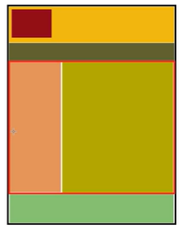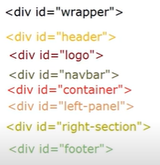 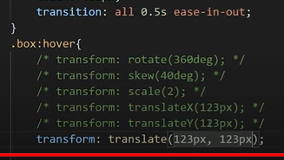

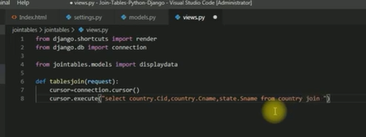

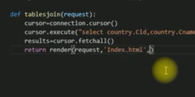

***Image upload in Django (geeeky)***

https://www.youtube.com/watch?v=5TwCVOyYR4U

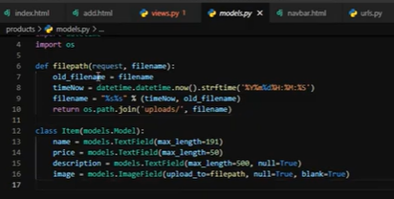

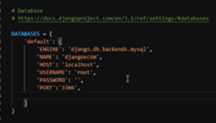

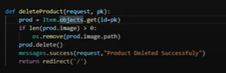

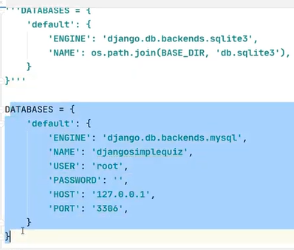

Generate Code A A A 0 0 1 0 0 1

Code_increase_alphabet(){

Return Next Aplhabet

}

Code_increase_number(){

Return next number

}

**Reference Tables**

home_ref_subject

🡺insert all the subjects

home_ref_level

🡺insert all the levels for whom question is made